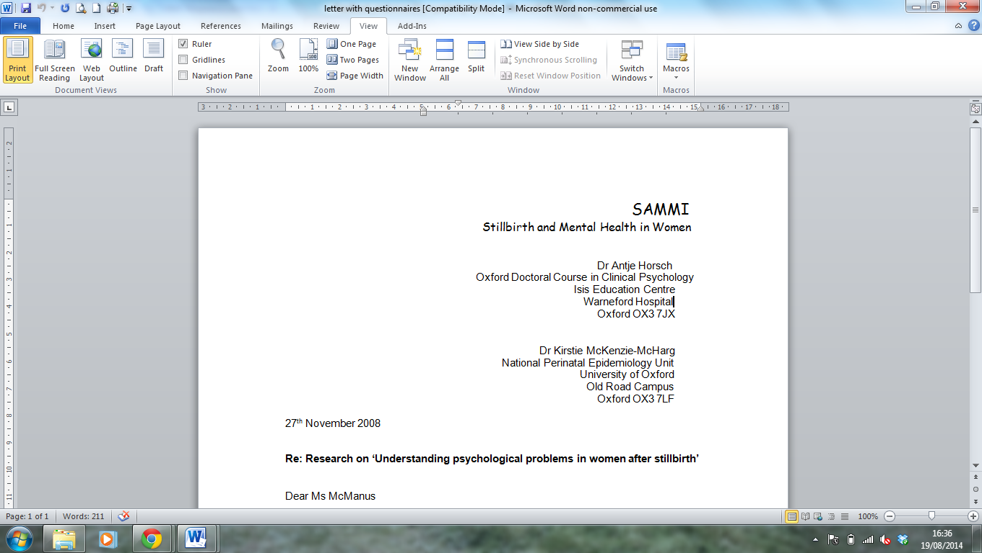Stillbirth and Mental Health in Women study
Summary of study findings
Introduction
Guidelines surrounding maternal contact with the stillborn infant have been contradictory over the past thirty years. Most studies have reported that seeing and holding the stillborn baby is associated with fewer anxiety and depressive symptoms among mothers of stillborn babies than not doing so [Râdestad et al., 1996; Trulsson & Râdestad, 2004; Cacciatore et al., 2008; Râdestad et al., 2009]. In contrast, a small number of studies suggest that contact with the stillborn infant can lead to poorer maternal mental health outcomes [Hughes et al, 2001; Hughes et al 2002]. There is a lack of research focusing on the maternal experience of this contact. This study aimed to investigate how mothers describe their experience of spending time with their stillborn baby and how they felt retrospectively about the decision they made to see and hold their baby or not.

Method
In depth interviews were conducted with twenty-one mothers three months after stillbirth in their homes. All interviews were audio recorded and lasted between 20 and 30 minutes. The interviews were semi-structured and aimed to elicit information about the woman’s experience of the stillbirth and her choices regarding contact with her stillborn infant. All interviews were transcribed and pseudonyms added to ensure confidentiality. The interview data was analysed manually to classify and code information according to key themes using Interpretive Phenomenological Analysis.

Results
Twenty-one mothers with a mean age of 34.4 years (SD = 5.2) were interviewed. Stillbirths occurred on average at 35.2 weeks (SD = 5.2) gestational age. All women saw their stillborn baby and nineteen women (90.5%) held their baby. The total average number of pregnancies (including the stillbirth) was 2.0 (SD = 1.2). Before the current stillbirth, three (14%) of the women interviewed had had a miscarriage, four (19%) had had a termination and one woman (4.8%) had had a previous stillbirth.

Six superordinate themes were identified and will be discussed in turn. The results highlight a range of issues particularly relevant to health professionals working with mothers following stillbirth.

Characteristics of Contact: Having time; Shared experience
Mothers talked about the importance of having time with their baby and being able to share the experience with those around them. Although it was extremely difficult at the time, spending time with their baby was a cathartic experience and the majority of mothers valued the time they had. Many participants also spoke about being able to share their experience with their partner and also with parents and members of their extended family. Involving those around them after the stillbirth was an important part of the process for mothers. The findings support previous research (Crawley et al., 2013) that highlights the importance of sharing memories of the stillborn baby to aid psychological adjustment.

Physicality: Fear of a dead body; Relief at well-formed body; Identifying family traits; Damage
A number of women described their fear and apprehension about seeing a dead body. They expressed concerns about what the baby would look like, as well as worries about how they would feel in response to being faced with a dead child. It is possible that this fear might prevent some mothers from choosing to see their baby. Therefore, these fears should be sensitively explored by health professionals and ways of coping should be discussed.

Consequently, a number of mothers felt a great sense of relief when they realised their baby was well-formed. However, a few women spoke about the damage and deterioration to their baby’s body and the negative implications that this had for them. Whilst most mothers found the physical appearance and seeing their stillborn baby a positive experience, allaying fears of seeing the dead body and the excitement of comparing the baby to family members, for others it was quite upsetting to see the damage and deterioration to their stillborn baby. It may therefore be important for health professionals to sensitively prepare mothers and fathers in cases where the body of their stillborn baby is damaged.

Emotional Experience: Positive experience/process; Maternal Pride; Grief
Mothers spoke at length about the emotional impact of having a stillbirth, including feelings of maternal pride at having a child, the intense pain and grief they felt at losing their child and the positive process that followed for some mothers. Whilst acknowledging intense sadness and loss following a stillbirth, a number of mothers described how the experience of seeing their baby had been a positive one and the fond memories they held of the time they spent with their baby. Some mothers also spoke of their pride at becoming a mother, and a positive change in how they felt about the stillbirth at the point of holding their baby for the first time. When looking back and describing the experience of spending time with their baby, the words “distraught”, “heart-breaking”, “angry” “pain” and “helpless” were over-riding expressions linked to grief used by participants. Particularly in these cases, professional support and opportunities for expressing feelings of helplessness, intense sadness and pain need to be provided.

Surreal Experience: Disbelief, Dissociation
As well as finding the experience of seeing their baby after the stillbirth emotional, a number of mothers also described the experience as surreal. Several women described feelings of disbelief. Others reported feelings of dissociation and described the experience as “blurred like it was a dream” and “like looking at a doll.....not a baby. Not like mine but somebody else’s”. Similarly, some mothers spoke about feeling disconnected from what they had experienced. For a few women, having a stillbirth resulted in strong feelings of disconnection from the world around them.

It is possible that certain aspects of how the contact with the baby is facilitated (e.g. how parents are prepared by staff, length of time spent with the baby, how the baby is presented by staff etc.) might increase the risk of dissociation occurring. Mothers and fathers who have dissociative experiences during contact with their stillborn baby might also be more vulnerable to developing subsequent symptoms of posttraumatic stress disorder or traumatic grief [Breh & Seidler, 2007]. It is therefore recommended that these couples are followed up and screened for symptoms of posttraumatic stress approximately one month after stillbirth.

Finality: Saying goodbye and Feeling sorry; Realising/accepting death
Having the opportunity to say goodbye and seeing their baby helped to bring about the realisation and acceptance for many mothers that their baby had died. One mother explained “I needed to say goodbye to her and I needed to say sorry”, sentiments echoed by a number of other mothers when looking back at the time they spent with their baby.

Participants also reported that seeing their baby following a stillbirth “helps you to cope with what’s happened”, as well as to accept that the baby had died. Having the opportunity to say goodbye and to see their baby brought about a sense of finality that for many mothers contributed to the healing process. It was something they felt they needed to do in order to move forward.

Decision: Satisfied with decision; Regrets about decision
Although the majority of mothers felt satisfied with their decision to see their baby following the stillbirth, a few mothers reported strong feelings of regret about the decision they took to not hold their stillborn baby. One mother also spoke of her sadness that her partner chose not to see their stillborn baby and the loss of shared experience as a family.

For the majority of mothers, the decision to see their stillborn baby was crucial to their ability to accept what had happened, to say goodbye, and then to move forward. This finding is in line with a recent study [Downe et al, 2013] and is in contrast with the recommendation that 'carers should avoid persuading parents to have contact with their stillborn baby, but should strongly support such desires when expressed' [RCOG, 2010]. Consistent with previous research, most of the mothers in this study found spending time with their stillborn baby helpful [Râdestad et al, 1996; Trulsson & Râdestad, 2004; Cacciatore et al, 2008; Downe et al, 2013].

Conclusions
Clearly, it is important to involve parents in all decisions regarding their contact with their stillborn baby. Results indicate that preparation before contact with the baby, professional support during the contact, and professional follow-up are crucial in order to prevent the development of maternal mental health problems. Fears of seeing a damaged or dead body should be sensitively explored and ways of coping discussed. Even in cases where mothers experienced intense distress during the contact with their stillborn baby, they still reported that having had this contact was important and that they had taken the right decision. Giving parents an informed choice by engaging in discussions about the possible benefits and risks of seeing their stillborn baby, rather than rigidly following perinatal bereavement protocols and guidelines, is crucial. What was reported to be helpful to some mothers who experienced stillbirth in this study was not always helpful to others. Consistent with previous research, our findings suggest that it may be appropriate for staff to recommend to parents that they consider having contact with their stillborn baby.

For more details, please see the recently published article: http://www.biomedcentral.com/1471-2393/14/203

References

Cacciatore J, Râdestad I, Frøen JF: Effects of contact with stillborn babies on maternal anxiety and depression. Birth 2008, 35:313–320.

Râdestad I, Nordin C, Steineck G, Sjogren B: Stillbirth is no longer managed as a nonevent: A nationwide study in Sweden. Birth 1996, 23:209–215.

Trulsson O, Râdestad I: The silent child—Mothers’ experiences before, during, and after stillbirth. Birth 2004, 31(3):189–195.

Râdestad I, Surkan PJ, Steineck G, Cnattingius S, Onleoev E, Dickman PW: Long-term outcomes for mothers who have or have not held their stillborn baby. Midwifery 2009, 25:422–429

Hughes P, Turton P, Hopper E, McGauley GA: Disorganized attachment behavior among infants born subsequent to stillbirth. J Child Psychiatry 2001, 42(6):791–801.

Hughes P, Turton P, Hopper E, Evans CDH: Assessment of guidelines for good practice in psychosocial care of mothers after stillbirth: A cohort study. Lancet 2002, 360(9327):114–118.

Crawley R, Lomax S, Ayers S: Recovering from stillbirth: the effects of making and sharing memories on maternal mental health. J Reprod Infant Psychol 2013, 31:195–207.

Breh DC, Seidler GH: Is peritraumatic dissociation a risk factor for PTSD? J Trauma Dissociation 2007, 8:53–69.

Downe S, Schmidt E, Kingdon C, Heazell A: Bereaved parents' experience of stillbirth in UK hospitals: a qualitative interview study. BMJ Open 2013, 3:e002237

Royal College of Obstetricians and Gynaecologists: Report of the RCOG working party on the management of perinatal deaths. London: Chameleon Press; 1985

